

Safeguarding Policy

July 2016 version: to be read in conjunction with Supplementary Guidance on Protecting Adults August 2014

Contents
Introduction and Organisational Commitment to Safeguarding 3
The Safeguarding Policy: Section 1 4
The Safeguarding Policy: Section 2 6
The Safeguarding Policy: Section 3 12
The Safeguarding Policy: Section 4 15
The Safeguarding Policy: Section 5 16
The Safeguarding Policy: Appendix 1 18
The Safeguarding Policy: Appendix 2 21
The Safeguarding Policy: Appendix 3 24
The Safeguarding Policy: Appendix 4 31
The Safeguarding Policy: Appendix 5 31
The Safeguarding Policy: Appendix 6 32
The Safeguarding Policy: Appendix 7 35


Where this sign is seen throughout this document, information about further sources of information can be found. The series can be accessed by all CCPAS members online.

Introduction and Organisational Commitment to Safeguarding
Thank you for taking the time to read this Safeguarding Policy. The policy is intended to shape the way that we think and act in relation to supporting those most vulnerable around us. Whether you are a children’s worker, pastoral carer for vulnerable adults, a church leader, departmental head or simply attending an Elim church, we want you to be aware of this policy.
‘Safeguarding is the process of protecting children and vulnerable adults from abuse or neglect, preventing impairment of their health and development, and ensuring they are living and growing in circumstances consistent with the provision of safe and effective care that enables them to have optimum life chances towards and throughout adulthood’
The Elim National Leadership Team acknowledges that safeguarding the vulnerable in our churches, activities and within the communities in which we work, both here and overseas is of paramount importance and reflects the nature of Jesus Christ.
It is therefore our intention to ensure that safeguarding is fully supported and maintained through the development of policies and procedures that are accessible and understood by all those that have a legitimate interest in the welfare of our children, young people and vulnerable adults. Our formal activities will be operated in line with this policy and support at a regional and national level will always be available to ensure effective, sensitive and robust implementation.
We believe that safeguarding is everyone’s business and that it is underpinned by scripture as a command to “love one another as I have loved you”. None of us are therefore exempt from understanding this as a way of expressing our faith and values.
This policy and its supporting guidance represent the National Leadership Team’s commitment to safeguarding. Within it you will find our adopted method of practice when working with and supporting children and vulnerable adults, whether formally or informally through the life of the church from ministerial training (see appendix 5) to church-based activities and international mission (see appendix 5). We commit to making it available to whoever requests it and to making our commitment to it publicly visible wherever possible. We also endorse the Safeguarding Statement contained at appendix 1 for use in your individual churches and within your various activities.
The policy and procedures have been divided into five sections covering all 10 Safeguarding Standards developed by the Churches’ Child Protection Advisory Service (CCPAS), which should be used in all settings with children, young people and vulnerable adults. This policy is not exhaustive and we would encourage you to refer to ‘Safe & Secure’ the CCPAS Safeguarding Manual available to all CCPAS members for more detailed information.

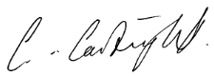
Chris Cartwright
General Superintendent
On behalf of the National Leadership Team

The Safeguarding Policy: Section 1
‘Safe & Secure’ Standard
1

Details of your place of worship/organisation

Name of Place of Worship / Organization: Elim Family Church Southwater

Address: Southwater Village Hall, Church Lane, Southwater RH139BT

Telephone No.: 01403612347

E-mail Address: deejaytala@hotmail.com

Charity Number(s)*: 251549

Regulators details (if any):
(e.g. OFSTED, CQC)
Insurance Company: Congregational (policies are underwritten by HDI Global Speciality SE UK Branch) Master Policy number: RC01020000 Sub Reference: RC01200303

The following is a brief description of Elim’s work and the type of activities we are involved in which may include children or vulnerable adults:

As a denomination Elim is seeking to build churches in the UK and across the world consisting of a rich diversity of cultures that are open to people of all nationalities, ages and backgrounds. Our churches meet together to worship God and to care for one another whilst also seeking to reach out to people in their immediate community, the wider area and across the world. We do this through an extensive variety of activities which may include among other things Sunday services, small groups, educational programmes, medical aid, alleviation of poverty and activities for the elderly, vulnerable adults, young people and children. As part of our mission we also have departments who seek to prepare and equip people for ministry in the local church, the workplace and for overseas mission.

* Applies to Elim Foursquare Gospel Alliance members
Our commitment to Safeguarding
As the Leadership†, we recognise the need to provide a safe and caring environment for children, young people and vulnerable adults. We acknowledge that children, young people and vulnerable adults can be the victims of physical, sexual and emotional abuse, and neglect.
We accept the UN Universal Declaration of Human Rights and the International Covenant of Human Rights, which states that everyone is entitled to “all the rights and freedoms set forth therein, without distinction of any kind, such as race, colour, sex, language, religion, political or other opinion, national or social origin, property, birth or other status”. We also concur with the Convention on the Rights of the Child which states that children should be able to develop their full potential, free from hunger and want, neglect and abuse. They have a right to be protected from “all forms of physical or mental violence, injury or abuse, neglect or negligent treatment or exploitation, including sexual abuse, while in the care of parent(s), legal guardian(s), or any other person who has care of the child.” We also accept the guidance laid out in Working Together to Safeguard Children 2013 and acknowledge that “safeguarding children is everyone’s responsibility” and that “everyone who comes into contact with children and families has a role to play.”
As a Leadership we have therefore adopted the procedures set out in this safeguarding policy in accordance with statutory guidance. We are committed to build constructive links with statutory and voluntary agencies involved in safeguarding.
The policy and appendices are based on the ten ‘Safe and Secure’ safeguarding standards published by the Churches' Child Protection Advisory Service (CCPAS) and have been prepared in line with the Elim National Leadership Team’s commitment to Safeguarding.
The Leadership undertakes to:
- endorse and follow all national and local safeguarding legislation and procedures, in addition to the international conventions outlined above.
- provide on-going safeguarding training for all its workers and will regularly review the operational guidelines attached.
- ensure that the premises meet the requirements of the Disability Discrimination Act 1995 and all other relevant legislation, and that it is welcoming and inclusive.
- support the Safeguarding Coordinator(s) in their work and in any action they may need to take in order to protect children and vulnerable adults.
- file a copy of the policy and practice guidelines with Elim’s National Safeguarding Coordinator
- file a copy of any amendments subsequently published in the same manner.
- not to allow the document to be copied by other organisations.
†Throughout this policy document, ‘Leadership’ refers to any body of individuals with overall responsibility for the church or organisation.

The Safeguarding Policy: Section 2

‘Safe & Secure’ Standards
2 & 7

Recognising and responding appropriately to an allegation or suspicion of abuse
UNDERSTANDING ABUSE & NEGLECT
Defining child abuse or abuse against a vulnerable adult is a difficult and complex issue. A person may abuse by inflicting harm, or failing to prevent harm. Children and adults in need of protection may be abused within a family, an institution or a community setting. Very often the abuser is known or in a trusted relationship with the child or vulnerable adult.
In order to safeguard those in our places of worship and organisations we adhere to the UN Convention on the Rights of the Child and have as our starting point as a definition of abuse, Article 19 which states:
1. Parties shall take all appropriate legislative, administrative, social and educational measures to protect the child from all forms of physical or mental violence, injury or abuse, neglect or negligent treatment, maltreatment or exploitation, including sexual abuse, while in the care of parent(s), legal guardian(s) or any other person who has the care of the child.
2. Such protective measures should, as appropriate, include effective procedures for the establishment of social programmes to provide necessary support for the child and for those who have the care of the child, as well as for other forms of prevention and for identification, reporting, referral, investigation, treatment and follow-up of instances of child maltreatment described heretofore, and, as appropriate, for judicial involvement.
Article 19, UN Convention on the Rights of the Child

Also for adults the UN Universal Declaration of Human Rights with particular reference to Article 5 which states:
No one shall be subjected to torture or to cruel, inhuman or degrading treatment or punishment.
Article 5, UN Universal Declaration of Human Rights

NB. Detailed definitions of abuse are included at appendix 3 of this policy.

Safeguarding Awareness
The Leadership is committed to on-going safeguarding training and development opportunities for all workers, developing a culture of awareness of safeguarding issues to help protect everyone. All our workers will receive induction training and undertake appropriate safeguarding training on a regular basis, which should cover signs and symptoms of abuse and how to respond as a minimum.
The Leadership will also ensure that children and vulnerable adults are provided with information on where to get help and advice in relation to abuse, discrimination, bullying or any other matter where they have a concern.
RESPONDING TO ALLEGATIONS OF ABUSE
Under no circumstances should a worker carry out their own investigation into an allegation or suspicion of abuse. Follow procedures as below (with reference to the flowchart at Appendix 4):
- The person in receipt of allegations or suspicions of abuse should report concerns as soon as possible to:
Name: Jo Taylor

Position: Safeguarding Coordinator

Telephone / Mobile: 07939057270

who is nominated by the Leadership to act on their behalf in dealing with the allegation or suspicion of neglect or abuse, including referring the matter on to the statutory authorities.

- In the absence of the Safeguarding Coordinator or, if the suspicions in any way involve the Safeguarding Coordinator, then the report should be made to:
Name: Lisa Burrell

Position: Deputy Safeguarding Coordinator

Telephone / Mobile: 07919360407

- If the suspicions implicate both the Safeguarding Co-ordinator and the Deputy, then the report should be made in the first instance to:

The Churches' Child Protection Advisory Service (C.C.P.A.S.)
P.O. Box 133 SWANLEY BR8 7UQ
Telephone: 0845 120 4550

Alternatively contact your local Social Services or the Police.

- Where the concern is about a child the Safeguarding Co-ordinator should contact Children’s Social Services:
The local Children’s Social Services office telephone number (office hours) is: 01403 229900
The out of hours emergency number is: 0330 222 6664
Where the concern is regarding an adult in need of protection, contact Adult Social Services or take advice from CCPAS as above.

The local Adult Social Services office telephone number (office hours) is: 01243 642121
The out of hours emergency number is: 01243 642121 (24 hours)

The Police Child Protection Team telephone number is: 101 ask for safeguarding

- Where required the Safeguarding Co-ordinator should then immediately inform strategic personnel within the denomination as follows:
Name: David Campbell
Position: Regional Leader
Telephone/Mobile: 07887991138
E-mail : dc@elimmetro.com
and
Name: Sarah Bale
Position: National Safeguarding Coordinator
Telephone/Mobile: 01684 588 913 or 07814 783855
E-mail : sarah.bale@elimhq.net

The National Safeguarding Coordinator will then immediately inform the organisations’ insurance company.

- Suspicions must not be discussed with anyone other than those nominated above. A written record of the concerns should be made in accordance with these procedures and kept in a secure place.
- Whilst allegations or suspicions of abuse will normally be reported to the Safeguarding Coordinator, the absence of the Safeguarding Coordinator or Deputy should not delay referral to Social Services, the Police or taking advice from CCPAS.
- The Leadership will support the Safeguarding Coordinator/Deputy in their role, and accept that any information they may have in their possession will be shared in a strictly limited way on a need to know basis.
- It is, of course, the right of any individual as a citizen to make a direct referral to the safeguarding agencies or seek advice from CCPAS, although the Leadership hope that members of the place of worship / organisation will use this procedure. If, however, the individual with the concern feels that the Safeguarding Coordinator/Deputy has not responded appropriately, or where they have a disagreement with the Safeguarding Coordinator(s) as to the appropriateness of a referral they are free to contact an outside agency direct. We hope by making this statement that the Leadership demonstrate its commitment to effective safeguarding and the protection of all those who are vulnerable.
The role of the safeguarding co-ordinator/ deputy is to collate and clarify the precise details of the allegation or suspicion and pass this information on to statutory agencies who have a legal duty to investigate. It is not the role of the Safeguarding Coordinator to investigate allegations and concerns.
Detailed procedures where there is a concern about a child:
ALLEGATIONS OF PHYSICAL INJURY, NEGLECT OR EMOTIONAL ABUSE
If a child has a physical injury, a symptom of neglect or where there are concerns about emotional abuse, the Safeguarding Coordinator/Deputy will:
- Seek medical help if needed. In urgent cases telephone 999.
- Contact Children’s Social Services (or CCPAS) for advice in cases of deliberate injury, if concerned about a child's safety or if a child is afraid to return home.
- Not tell the parents or carers unless advised to do so, having contacted Children’s Social Services.
- For lesser concerns, (e.g. poor parenting), encourage parent/carer to seek help, but not if this places the child at risk of significant harm.
- Where the parent/carer is unwilling to seek help, offer to accompany them. In cases of real concern, if they still fail to act, contact Children’s Social Services direct for advice.
- Seek and follow advice given by CCPAS on 0845 120 4550 (who will confirm their advice in writing) if unsure whether or not to refer a case to Children’s Social Services.

ALLEGATIONS OF SEXUAL ABUSE
In the event of allegations or suspicions of sexual abuse, the Safeguarding Co-ordinator/Deputy will:
- Contact the Children’s Social Services Department Duty Social Worker for children and families or Police Child Protection Team direct. They will NOT speak to the parent/carer or anyone else.
- Seek and follow the advice given by CCPAS if, for any reason they are unsure whether or not to contact Children’s Social Services/Police. CCPAS will confirm its advice in writing for future reference.
Detailed procedures where there is a concern about a vulnerable adult:
SUSPICIONS OR ALLEGATIONS OF PHYSICAL OR SEXUAL ABUSE
If a vulnerable adult has a physical injury or symptom of sexual abuse the Safeguarding Co-ordinator/Deputy will:
- Discuss any concerns with the individual themselves giving due regard to their autonomy, privacy and rights to lead an independent life.
- If the vulnerable adult is in immediate danger or has sustained a serious injury contact the Emergency Services, informing them of any suspicions.
- For advice contact the Adult Social Care Vulnerable Adults Team who have responsibility under Section 47 of the NHS and Community Care Act 1990 and government guidance, ‘No Secrets’, to investigate allegations of abuse. Alternatively CCPAS can be contacted for advice.
Further guidance about signs and symptoms of abuse of vulnerable adults and reporting and responding to abuse of vulnerable adults can be found in the separate document ‘Guidance for Protecting Vulnerable Adults’.
Detailed procedure where there is an allegation against a person who works with children:
ALLEGATIONS OF ABUSE AGAINST A PERSON WHO WORKS WITH CHILDREN
If an accusation is made against a worker (whether a volunteer or paid member of staff) whilst following the procedure outlined above, the Safeguarding Co-ordinator will without delay inform:
- the National Safeguarding Coordinator (and in the National Safeguarding Coordinator’s absence the Elim Churches Administrator at Head Office);
- the local Children’s Social Services (following the Local Safeguarding Children Board (LSCB) procedures) in regards to the suspension of the worker, and discuss
- also making a referral to a Local Authority Designated Officer (LADO) as follows:
Name:

Position: Local Authority Designated Officer

Telephone / Mobile: 0330222666442

NB. There may also be a requirement under law to make a referral to the Disclosure and Barring Service (DBS) who hold the lists of people barred from working with children and vulnerable adults – this will require discussion with the LADO (please note that LADO’s exist only in England – other nations should use the usual channels of communication with children’s services or their equivalent).

DBS referrals - forms and guidance

Elim Supplementary Guidance on Protection of Vulnerable Adults is available on ElimNet

The Safeguarding Policy: Section 3

‘Safe & Secure’ Standards
3 & 4

Prevention
Safer Recruitment
Having in place a range of mechanisms and understood practices surrounding the recruitment of staff and volunteers is an essential element in our safeguarding arrangements. Safer recruitment practices will assist us in ensuring that we have the opportunity to prevent those we would not want working with children and vulnerable adults from doing so at the earliest point.
The Leadership will ensure all workers will be appointed, trained, supported and supervised in accordance with government guidance on safe recruitment. This includes ensuring that:
- There is a written role description / person specification for the post
- Those applying have completed a standard application form and a self-declaration form
- Those short listed have ALL been interviewed
- Roles and attitudes regarding safeguarding have been discussed at interview
- Written references have been obtained for ALL candidates, and followed up verbally where appropriate
- A Disclosure & Barring Service (DBS) disclosure is completed (we will comply with Code of Practice requirements concerning the fair treatment of applicants and the handling of information) prior to the successful candidate commences employment
- Qualifications where relevant have been verified
- A suitable induction training programme (including safeguarding) is provided for the successful applicant
- The successful applicant completes a probationary period
- The applicant has been given a copy of this safeguarding policy and knows how to report concerns.
Safer recruitment practices should be used regardless of the setting or activity where workers are working with either children or vulnerable adults. In addition, the same principles and practices should be adopted for workers undertaking international missions (see Appendix 5) and for prospective entrants to vocational/ministerial courses being provided by Regents Theological College (see Appendix 5).
‘Help...I want to recruit workers safely’ CCPAS booklet.
‘Recruiting Safely: helping to keep children and young people safe’ (CWDC, 2009).

Management of Workers – Codes of Conduct
As Leadership we are committed to supporting all workers and ensuring they receive support and supervision. All workers will be issued with a code of conduct towards children, young people and vulnerable adults. The Leadership undertakes to follow the principles found within the ‘Abuse Of Trust ‘guidance issued by the Home Office and it is therefore unacceptable for those in a position of trust to engage in any behaviour which might allow a sexual relationship to develop for as long as the relationship of trust continues.
A code of conduct towards children, young people and vulnerable adults should be drawn up which all workers agree to follow. It is important there is a culture of dignity and respect towards those being cared for. This can be achieved by workers:
- understanding the organisation’s safeguarding policy and good working practice
- listening to children, young people and vulnerable adults.
- respecting boundaries and privacy of those being cared for
- knowing how to deal with issues of discipline in line within the organisation’s code of conduct
- developing an awareness of disability issues as well as issues of equality and inclusion
‘Caring for the Young & Vulnerable’ (Home Office, 1999)

Management of Workers – Training and Supervision
All workers, paid or voluntary, should be provided with appropriate training and given the opportunity to develop their skills as well as feel supported and valued by the organisation for which they work. When this happens, workers will be more inclined to express concerns over issues that arise and it will also help to ensure a high level of care, professionalism and expertise towards those being cared for.
As a Leadership, we commit to ensuring all workers are supervised (where possible by a named individual who arranges regular meetings) where concerns or issues can be raised, work related or personal. It is also the role of the supervisor to ensure all training needs are met. Where supervision with a named individual is not possible, or impractical, group supervision may be used as an alternative as this can maximise resources and allows for the sharing of issues and concerns.
Management of Workers - Team Meetings
The leadership recognises the importance of team meetings. These should be convened on a regular basis and should provide an opportunity for ideas and issues to be aired, concerns expressed and feedback given.

Management of Workers – Whistleblowing
In addition to effective management of allegations against staff, there needs to be a mechanism in place such as supervision or meetings with a team leader for workers to be able to raise any concerns (e.g. improper actions or omissions) about other workers, with impunity. Commonly known as ‘whistleblowing’, the reporting principles are contained in the Public Disclosure Act 1998. Further information and advice can be obtained from Public Concern at Work:
Public Concern at Work
7-14 Great Dover Street
LONDON
SE1 4YR
Tel: 020 7404 6609
E-mail: whistle@pcaw.co.uk

The Safeguarding Policy: Section 4
‘Safe & Secure’ Standards
8 & 9
Pastoral Care
Supporting those affected by abuse
The Leadership is committed to offering pastoral care, working with statutory agencies as appropriate, and support to all those who have been affected by abuse who have contact with or are part of the place of worship / organisation.
Pastoral care is varied by nature and you should ensure that you have appropriate support and permissions before you embark upon supporting somebody with the often complex issues created by past abuse. If you are concerned about your ability to provide appropriate pastoral care and/or counselling to individuals in these circumstances, you should contact the CCPAS 24 Hour Helpline on 0845 120 45 50. CCPAS are able to provide limited advice and may be able to suggest organisations or individuals who may be able to assist further.
Alternatively, you should contact the Association of Christian Counsellors (ACC) who will be able to put you in contact with trained individuals who may be able to offer support. ACC also produce a Pastoral Skills training course that can be delivered in your church/organisation by somebody experienced in pastoral care.
– Effective Listening
Working with offenders
When someone attending the place of worship / organisation is known to have abused children or vulnerable adults or has been charged but not yet convicted of abusing children or vulnerable adults, the Leadership will supervise the individual concerned and offer pastoral care, but in its safeguarding commitment to the protection of children and vulnerable adults, set boundaries for that person which they will be expected to keep. This may involve the use of risk assessments and supervision agreements and contact with probation and/or the police.
Pastoral care will be offered without prejudice to all those who require it. This may also include a known offender. Where pastoral care is offered to both the person affected by abuse and the known offender, this should be offered by different people who are able to support those concerned impartially and effectively.
‘Help...a sexual offender has joined my church’ CCPAS booklet

The Safeguarding Policy: Section 5

‘Safe & Secure’ Standards
5, 6 and 10

Practice Guidelines
As an organisation / place of worship working with children, young people and vulnerable adults we wish to operate and promote good working practice. This will enable workers to run activities safely, develop good relationships and minimise the risk of false accusation.
As well as the general Code of Conduct for workers we also have access to specific good practice guidelines for a range of activities that can be adopted. For detailed information see ‘Safe & Secure’ Manual - Standard 5.
Working in Partnership
The diversity of organisations and settings means there can be great variation in practice when it comes to safeguarding children, young people and vulnerable adults. This can be because of cultural tradition, belief and religious practice or understanding, for example, of what constitutes abuse.
We therefore have clear guidelines in regards to our expectations of those with whom we work in partnership, whether in the UK or not. We will discuss with all partners our safeguarding expectations and have a partnership agreement for safeguarding. It is also our expectation that any organisation using our premises‡, as part of a letting agreement will have their own policy that meets CCPAS’ safeguarding standards.
Good communication is essential in promoting safeguarding, both to those we wish to protect, to everyone involved in working with children and vulnerable adults and to all those with whom we work in partnership. This safeguarding policy is just one means of promoting safeguarding.

‘Guidance for Safer Working Practice for Adults who Work with Children and Young People’ (DCSF, 2009).

‡ For additional information on hiring out your building please see ElimNet

Approvals
Signed By:
Printed Name:
Position: On behalf of the Leadership
Date:

Signed By:
Printed Name:
Position: Safeguarding Coordinator
Date:

Signed By:
Printed Name:
Position: Deputy Safeguarding Coordinator
Date:

Signed By:
Printed Name:
Position:
Date:

Signed By:
Printed Name:
Position:
Date:

Signed By:
Printed Name:
Position:
Date:

This policy will be reviewed annually and amendments made as necessary. All revised versions will be forwarded to Elim’s National Safeguarding Coordinator.

The Safeguarding Policy: Appendix 1
Leadership Safeguarding Statement
The Leadership recognises the importance of its ministry /work with children and young people and adults in need of protection and its responsibility to protect everyone entrusted to our care.
The following statement was agreed by the leadership on:

This place of worship/organisation is committed to the safeguarding of children and vulnerable adults and ensuring their well-being. Specifically:
- We recognise that we all have a responsibility to help prevent the physical, sexual, emotional abuse and neglect of children and young people (those under 18 years of age) and to report any such abuse that we discover or suspect.
- We believe every child should be valued, safe and happy. We want to make sure that children we have contact with know this and are empowered to tell us if they are suffering harm.
- All children and young people have the right to be treated with respect, to be listened to and to be protected from all forms of abuse.
- We recognise that we all have a responsibility to help prevent the physical, sexual, psychological, financial and discriminatory abuse and neglect of vulnerable adults and to report any such abuse that we discover or suspect.
- We recognise the personal dignity and rights of vulnerable adults and will ensure all our policies and procedures reflect this.
- We believe all adults should enjoy and have access to every aspect of the life of the place of worship/organisation unless they pose a risk to the safety of those we serve.
- We undertake to exercise proper care in the appointment and selection of all those who will work with children and vulnerable adults.

We are committed to:
- Following the requirements for UK legislation in relation to safeguarding children and vulnerable adults and good practice recommendations.
- Respecting the rights of children as described in the UN Convention on the Rights of the Child.
- Implementing the requirements of legislation in regard to people with disabilities.
- Ensuring that workers adhere to the agreed procedures of our safeguarding policy.
- Keeping up to date with national and local developments relating to safeguarding.
- Following any denominational or organisational guidelines in relation to safeguarding children and adults in need of protection.
- Supporting the safeguarding co-ordinator/s in their work and in any action they may need to take in order to protect children/vulnerable adults.
- Ensuring that everyone agrees to abide by these recommendations and the guidelines established by this place of worship/organisation.
- Supporting parents and families and ensuring that the place of worship/organisation is a safe place for all
- Nurturing, protecting and safeguarding of children and young people
- Supporting, resourcing, training, monitoring and providing supervision to all those who undertake this work.
- Supporting all in the place of worship/organisation affected by abuse.
- Adopting and following the ‘Safe and Secure’ safeguarding standards developed by the Churches’ Child Protection Advisory Service.

We recognise:
- Children’s Social Services (or equivalent) has lead responsibility for investigating all allegations or suspicions of abuse where there are concerns about a child. Adult Social Care (or equivalent) has lead responsibility for investigating all allegations or suspicions of abuse where there are concerns about a vulnerable adult.
- Where an allegation suggests that a criminal offence may have been committed then the police should be contacted as a matter of urgency.
- Where working outside of the UK (in international mission activity), safeguarding practice maintains its importance and allegations or concerns will be reported in line with the procedures detailed in Appendix 5.
- Safeguarding is everyone’s responsibility.

We will review this statement and our policy and procedures annually.
If you have any concerns for a child or vulnerable adult then speak to one of the following who have been approved as safeguarding co-ordinators for this place of worship/organisation.
Name: Jo Taylor

Position: Child Safeguarding Coordinator

Name: Lisa Burrell

Position: Deputy Child Safeguarding Coordinator

Name: Jo Taylor

Position: Adult Safeguarding Coordinator

Name: Lisa Burrell

Position: Deputy Adult Safeguarding Coordinator

A copy of the full policy and procedures is available from the Safeguarding Coordinator who is:
Jo Taylor

A copy of our safeguarding policy has been lodged with Elim Headquarters

Signed by leadership/organisation
Signed By:
Date:

This statement (or brief summary) could be exhibited on the organisation’s premises. Alternatively, or in addition, the poster (Appendix 2) could be displayed and this lengthy statement kept elsewhere. The statement might also be used on the organisation’s website.

The Safeguarding Policy: Appendix 2
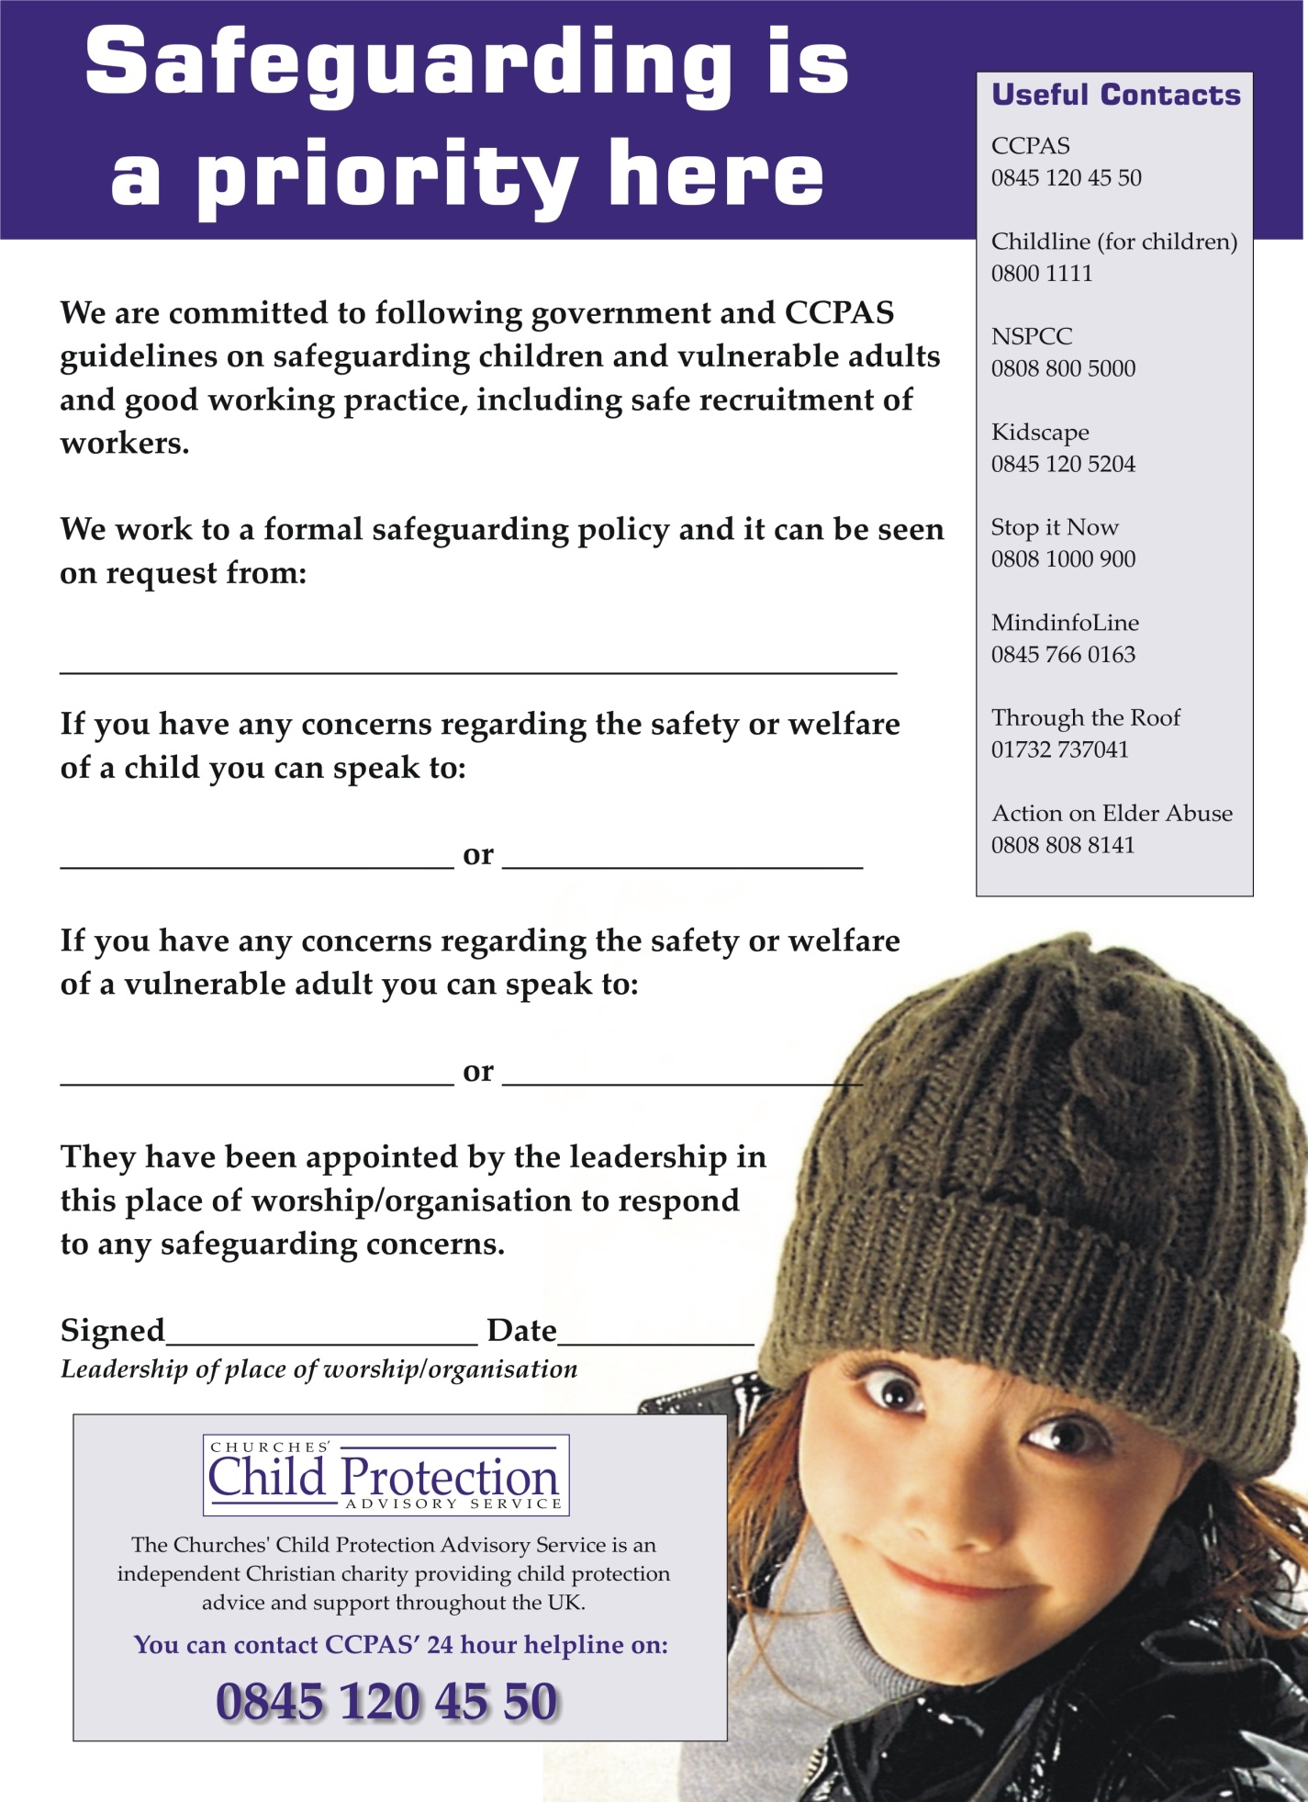

The Safeguarding Policy: Appendix 3
Statutory Definitions of Abuse (Children)
Abuse and neglect are forms of maltreatment of a child. Somebody may abuse or neglect a child by inflicting harm, or by failing to act to prevent harm.
Children may be abused in a family or in an institutional or community setting; by those known to them or, more rarely, by a stranger. They may be abused by an adult or adults or another child or children.
Child protection legislation throughout the UK is based on the United Nations Convention on the Rights of the Child. Each nation within the UK has incorporated the convention within its legislation and guidance.
ENGLAND
The four definitions of abuse below operate in England based on the government guidance ‘Working Together to Safeguard Children (2013)’.
What is abuse and neglect?
Abuse and neglect are forms of maltreatment of a child. Somebody may abuse or neglect a child by inflicting harm, or by failing to act to prevent harm. Children may be abused in a family or in an institutional or community setting, by those known to them or, more rarely, by a stranger for example, via the internet. They may be abused by an adult or adults, or another child or children.
Physical abuse
Physical abuse may involve hitting, shaking, throwing, poisoning, burning or scalding, drowning, suffocating, or otherwise causing physical harm to a child. Physical harm may also be caused when a parent or carer fabricates the symptoms of, or deliberately induces, illness in a child.
Emotional abuse
Emotional abuse is the persistent emotional maltreatment of a child such as to cause severe and persistent adverse effects on the child’s emotional development.
It may involve conveying to children that they are worthless or unloved, inadequate, or valued only insofar as they meet the needs of another person. It may include not giving the child opportunities to express their views, deliberately silencing them or ‘making fun’ of what they say or how they communicate. It may feature age or developmentally inappropriate expectations being imposed on children. These may include interactions that are beyond the child’s developmental capability, as well as overprotection and limitation of exploration and learning, or preventing the child participating in normal social interaction. It may involve seeing or hearing the ill-treatment of another. It may involve serious bullying (including cyberbullying), causing children frequently to feel frightened or in danger, or the exploitation or corruption of children. Some level of emotional abuse is involved in all types of maltreatment of a child, though it may occur alone.
Sexual abuse
Sexual abuse involves forcing or enticing a child or young person to take part in sexual activities, not necessarily involving a high level of violence, whether or not the child is aware of what is happening. The activities may involve physical contact, including assault by penetration (for example, rape or oral sex) or non-penetrative acts such as masturbation, kissing, rubbing and touching outside of clothing. They may also include non-contact activities, such as involving children in looking at, or in the production of, sexual images, watching sexual activities, encouraging children to behave in sexually inappropriate ways, or grooming a child in preparation for abuse (including via the internet). Sexual abuse is not solely perpetrated by adult males. Women can also commit acts of sexual abuse, as can other children.
Neglect
Neglect is the persistent failure to meet a child’s basic physical and/or psychological needs, likely to result in the serious impairment of the child’s health or development. Neglect may occur during pregnancy as a result of maternal substance abuse. Once a child is born, neglect may involve a parent or carer failing to:
- provide adequate food, clothing and shelter (including exclusion from home or abandonment);
- protect a child from physical and emotional harm or danger;
- ensure adequate supervision (including the use of inadequate care-givers); or
- ensure access to appropriate medical care or treatment.
It may also include neglect of, or unresponsiveness to, a child’s basic emotional needs.
WALES
The following definitions of child abuse are recommended as criteria throughout Wales by the Department of Health, Department for Education and Skills and the Home Office in their joint document, Working Together to Safeguard and Promote the Welfare of Children (2000).
Physical Abuse
Physical abuse may involve hitting, shaking, throwing, poisoning, burning or scalding, drowning, suffocating or otherwise causing physical harm to a child. Physical harm may also be caused when a parent or carer feigns the symptoms of, or deliberately causes ill health to a child whom they are looking after. This is commonly described using terms such as 'factitious illness by proxy' or 'Munchausen Syndrome by proxy'.
Emotional Abuse
Emotional abuse is the persistent emotional ill-treatment of a child such as to cause severe and continuous adverse effects on the child's emotional development. It may involve conveying to children that they are worthless or unloved, inadequate or valued only sofar as they meet the needs of another person. It may feature age or developmentally inappropriate expectations being imposed on children. It may involve causing children to feel frightened or in danger, or the exploitation or corruption of children. Some level of emotional abuse is involved in all types of ill-treatment of a child, though it may occur alone.
Sexual Abuse
Sexual abuse involves forcing or enticing a child or young person to take part in sexual activities, whether or not the child is aware of what is happening. The activities may involve physical contact, including penetrative (e.g. rape or buggery) or non-penetrative acts. They may include non-contact activities, such as involving children in looking at, or in the production of, pornographic material or watching sexual activities, or encouraging children to behave in sexually inappropriate ways.
Neglect
Neglect is the persistent failure to meet a child's basic physical and/or psychological needs, likely to result in the serious impairment of the child's health or development. It may involve a parent or carer failing to provide adequate food, shelter and clothing, failing to protect a child from physical harm or danger, or the failure to ensure access to appropriate medical care or treatment. It may also include neglect of, or unresponsiveness to, a child's basic emotional needs.
SCOTLAND
In 2010, The Scottish Government published a guide to inter-agency co-operation and good practice in relation to protecting children called ‘National Guidance for Child Protection in Scotland’. This publication set out a framework for collaboration between Social Work Departments and other agencies.
Categories of Abuse
Abuse and neglect are forms of maltreatment of a child. Somebody may abuse or neglect a child by inflicting, or by failing to act to prevent, significant harm to the child. Children may be abused in a family or in an institutional setting, by those known to them or, more rarely, by a stranger.
The following definitions show some of the ways in which abuse may be experienced by a child but are not exhaustive, as the individual circumstances of abuse will vary from child to child.
Physical Abuse
Physical abuse is the causing of physical harm to a child or young person. Physical abuse may involve hitting, shaking, throwing, poisoning, burning or scalding, drowning or suffocating. Physical harm may also be caused when a parent or carer feigns the symptoms of, or deliberately causes, ill health to a child they are looking after.
Sexual Abuse
Sexual abuse is any act that involves the child in any activity for the sexual gratification of another person, whether or not it is claimed that the child either consented or assented. Sexual abuse involves forcing or enticing a child to take part in sexual activities, whether or not the child is aware of what is happening. The activities may involve physical contact, including penetrative or non-penetrative acts. They may include non-contact activities, such as involving children in looking at, or in the production of, pornographic material or in watching sexual activities, using sexual language towards a child or encouraging children to behave in sexually inappropriate ways.
Emotional Abuse
Emotional abuse is persistent emotional neglect or ill treatment that has severe and persistent adverse effects on a child’s emotional development. It may involve conveying to a child that they are worthless or unloved, inadequate or valued only insofar as they meet the needs of another person. It may involve the imposition of age- or developmentally-inappropriate expectations on a child. It may involve causing children to feel frightened or in danger, or exploiting or corrupting children. Some level of emotional abuse is present in all types of ill treatment of a child; it can also occur independently of other forms of abuse.
Physical Neglect
Neglect is the persistent failure to meet a child’s basic physical and/or psychological needs, likely to result in the serious impairment of the child’s health or development. It may involve a parent or carer failing to provide adequate food, shelter and clothing, to protect a child from physical harm or danger, or to ensure access to appropriate medical care or treatment. It may also include neglect of, or failure to respond to, a child’s basic emotional needs. Neglect may also result in the child being diagnosed as suffering from “non-organic failure to thrive”, where they have significantly failed to reach normal weight and growth or development milestones and where physical and genetic reasons have been medically eliminated. In its extreme form children can be at serious risk from the effects of malnutrition, lack of nurturing and stimulation. This can lead to serious long-term effects such as greater susceptibility to serious childhood illnesses and reduction in potential stature. With young children in particular, the consequences may be life-threatening within a relatively short period of time.
NORTHERN IRELAND
The following definitions of child abuse are recommended as criteria in Northern Ireland by the Department of Health, Social Services and Public Safety in the document ‘Co-operating to Safeguard Children (2003).
Types of Abuse
Child abuse occurs when a child is neglected, harmed or not provided with proper care. Children may be abused in many settings, in a family, in an institutional setting by those known to them or more rarely, by a stranger. There are different types of abuse and a child may suffer more than one of them.
Physical Abuse
Physical Abuse is the deliberate physical injury to a child, or the wilful or neglectful failure to prevent physical injury or suffering. This may include hitting, shaking, throwing, poisoning, burning or scalding, drowning, suffocating, confinement to a room or cot, or inappropriately giving drugs to control behaviour.
Emotional Abuse
Emotional abuse is the persistent emotional ill-treatment of a child such as to cause severe and continuous adverse effects on the child's emotional development. It may involve conveying to children that they are worthless or unloved, inadequate or valued only insofar as they meet the needs of another person. It may involve causing children to feel frightened or in danger, or the exploitation or corruption of children. Some level of emotional abuse is involved in all types of ill-treatment of a child, though it may occur alone. Domestic violence, adult mental health problems and parental substance misuse may expose children to emotional abuse.
Sexual Abuse
Sexual abuse involves forcing or enticing a child or young person to take part in sexual activities. The activities may involve physical contact, including penetrative or non-penetrative acts. They may include non-contact activities, such as involving children in looking at, or in the production of, pornographic material or watching sexual activities, or encouraging children to behave in sexually inappropriate ways*.
Neglect
Neglect is the persistent failure to meet a child's basic physical and/or psychological needs, likely to result in significant harm. It may involve a parent or carer failing to provide adequate food, shelter and clothing, failing to protect a child from physical harm or danger, or the failure to ensure access to appropriate medical care or treatment. It may also include non-organic failure to thrive.
Significant Harm
The legislation defining the circumstances in which compulsory intervention in family life is justified in the best interests of children is based on the concept of ‘significant harm’. The relevant Articles in the Children Order are Articles 2(2) and 50(3). There are no absolute criteria for judging what constitutes significant harm. However, they may include the degree, extent, duration and frequency of harm. Sometimes a single traumatic event may constitute significant harm e.g. violent assault, sexual assault, suffocating or poisoning. More often, significant harm is a series of events, both acute and longstanding, which interrupt, change or damage the child’s physical and/or psychological development. Some children live in family and social circumstances where health and development are neglected. For them, it is the corrosiveness of long term emotional, physical and/or sexual abuse that causes impairment, sometimes to the extent of constituting significant harm.
*Sexual activity involving a child who is capable of giving informed consent on a matter, while illegal, may not necessarily constitute sexual abuse as defined for the purposes of this guide. One example, which would fall into this category is a sexual relationship between a 16 year old and her 18 year old boyfriend. The decision to initiate child protection action in such cases is a matter for professional judgement and each case should be considered individually. The criminal aspects will, of course, be dealt with by the police.
Statutory Definitions of Abuse (Vulnerable Adults)
The following definition of abuse is laid down in ‘No Secrets: Guidance on developing and implementing multi-agency policies and procedures to protect vulnerable adults from abuse (Department of Health 2000):
‘Abuse is a violation of an individual’s human and civil rights by any other person or persons. In giving substance to that statement, however, consideration needs to be given to a number of factors:
Abuse may consist of a single act or repeated acts. It may be physical, verbal or psychological, it may be an act of neglect or an omission to act, or it may occur when a vulnerable person is persuaded to enter into a financial or sexual transaction to which he or she has not consented, or cannot consent. Abuse can occur in any relationship and may result in significant harm to, or exploitation of, the person subjected to it’.
Physical Abuse
This is the infliction of pain or physical injury, which is either caused deliberately, or through lack of care.
Sexual Abuse
This is the involvement in sexual activities to which the person has not consented or does not truly comprehend and so cannot give informed consent, or where the other party is in a position of trust, power or authority and uses this to override or overcome lack of consent.
Psychological or Emotional Abuse
These are acts or behaviour, which cause mental distress or anguish or negates the wishes of the vulnerable adult. It is also behaviour that has a harmful effect on the vulnerable adult’s emotional health and development or any other form of mental cruelty.
Financial or Material Abuse
This is the inappropriate use, misappropriation, embezzlement or theft of money, property or possessions.
Neglect or Act of Omission
This is the repeated deprivation of assistance that the vulnerable adult needs for important activities of daily living, including the failure to intervene in behaviour which is dangerous to the vulnerable adult or to others. A vulnerable person may be suffering from neglect when their general well being or development is impaired
Discriminatory Abuse
This is the inappropriate treatment of a vulnerable adult because of their age, gender, race, religion, cultural background, sexuality, disability etc. Discriminatory abuse exists when values, beliefs or culture result in a misuse of power that denies opportunity to some groups or individuals. Discriminatory abuse links to all other forms of abuse.
Institutional Abuse
This is the mistreatment or abuse of a vulnerable adult by a regime or individuals within an institution (e.g. hospital or care home) or in the community. It can be through repeated acts of poor or inadequate care and neglect or poor professional practice.
See Elim Supplementary Guidance on Protection of Vulnerable Adults available on ElimNet

The Safeguarding Policy: Appendix 4
Flow Chart for Action (Children & Young People)
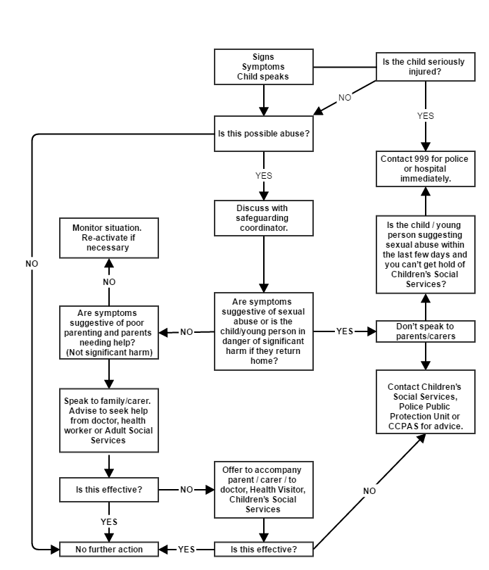

The Safeguarding Policy: Appendix 5
Flow Chart for Action (Vulnerable Adults)

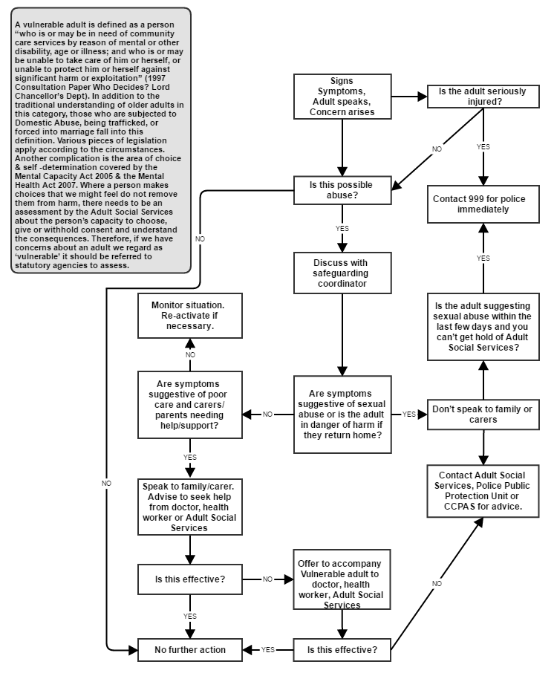
The Safeguarding Policy: Appendix 6
International Missions
Introduction
Safeguarding the vulnerable is no less important overseas than at home in the UK. In many ways there is greater need to ensure that our workers and the way in which they work are in adherence to our safeguarding policy as the opportunity of abuse is often far greater.
The safeguarding policy that has been adopted by the Elim National Leadership Team, therefore applies to all our Elim International Missions workers and volunteers overseas; whether planting/establishing churches within indigenous communities, visiting on short-term mission or placed as a long-term missionary in our many locations around the world.
Prevention of abuse
It is recognised that the cultures within which international missions are often working may adopt different standards to the care and treatment of children and young people. Nevertheless, the standards and principles adopted within the UK are expected to apply in international mission situations. The maltreatment of children and young people is contrary to Biblical values and practices and therefore cannot be tolerated.
Due regard will need to be given to the cultures within which activities are taking place, however under the expectation of applying UK standards to the practice of missions workers, some guidance may be useful.
Workers should:
- be able to recognise situations which may present risks
- plan and organise the work and workplace so as to minimise risks as far as possible and be visible to other adults when working and talking with children
- take particular care for the needs of disabled children and other vulnerable children as research has shown that abuse can often go unrecognised and unreported due to people's attitudes and assumptions about disability
- ensure that others know where interviews of children are taking place and that someone else is around in the building
Workers should not:
- spend excessive time alone with children
- take children to their personal home, or to stay overnight, especially where they will be alone with you
- leave any person under 16 in charge of any children of any age. However, some local/national legislation may require this to be 18 years of age. Nor should children or young people attending any group be left alone at any time.
- hit or otherwise physically assault children
- develop physical/sexual relationships with children
- develop relationships with children which could in any way be deemed exploitative or abusive
- use language, make suggestions or offer advice, which is inappropriate, offensive or abusive.
- do things for children of a personal nature that they can do for themselves
- act in ways intended to shame, humiliate, belittle or degrade children, or otherwise perpetrate any form of emotional abuse, discriminate against, show differential treatment, or favour particular children to the exclusion of others.
Responding & Reporting Mechanisms
Elim International Missions has a designated Safeguarding Coordinator responsible for safe recruitment including DBS disclosures and for ensuring that applicants are fully apprised of the safeguarding policy. All incidents, allegations or concerns must be reported to the International Missions Director who will then liaise with the appropriate authorities to ensure good practice is facilitated in relation to the reporting of any allegations of abuse.
Where an allegation is made against a worker (whether located long-term on mission or visiting on short-term mission), the International Missions Director must be informed immediately whereupon the standard process described in Section 2 of Safeguarding Policy will apply in relation to contacting the appropriate authorities in the UK to discuss further action. The International Missions Director will then ensure that appropriate action can be taken including where appropriate for the Crisis Management Team to be convened, which would include:
- International Missions Director (Chair);
- General Superintendent;
- Administrator;
- Sending Minister/Leader;
- Additional person if required with relevant expertise
If an allegation is made against a worker, that worker must be removed from their duties or prevented from having any further contact with children and young people or vulnerable adults immediately whilst necessary action is taken.
Due account must always be taken of the laws and frameworks in place within any country in which Elim operates. In many cases, practice, values and beliefs in relation to safeguarding the vulnerable will be different to the UK. However, care must always be taken to ensure that the rights of the individuals concerned are upheld (see the UN Convention on Human Rights and UN Convention on the Rights of the Child).

The Safeguarding Policy: Appendix 7
Regents Theological College
Introduction

Regents Theological College (RTC) is the gateway to the ministry for many of our church leaders and pastors. Among the many courses that are taught, there are a number that are vocational or ministerial in their focus and delivery often involving placements in places of worship, missions and other faith-based organisations and activities.
For this reason, the National Leadership Team believes it is essential that we ensure we have robust mechanisms in place to prevent those who are unsuitable for working with children, young people and vulnerable adults access to these vulnerable people by virtue of the training they receive from Elim.
Safer Recruitment of Students (See also Page 11)
Since all courses at RTC are vocational in nature and might confer upon graduates the expectation or opportunity to work in places where they might be in contact with vulnerable people, the National Leadership Team is committed to ensuring that such students are suitable for these roles and will ensure that systems are in place to make appropriately robust and safe recruitment decisions. Entry to such courses must be viewed as a recruitment process and equally robust processes applied as to those applying to work in our churches and activities.
The Application Process
Potential students will apply for courses in the normal manner. However, in the same way as for applicants for positions involving access to children or vulnerable adults, a self-disclosure will be required as a part of the application process and applicants will be informed of the need for the College to take up character references and DBS checks prior to final acceptance onto the course. DBS checks will not be taken up until a conditional offer has been accepted by a prospective student.
Where information is declared by the DBS, the usual process for determining suitability will be applied in consultation with the National Safeguarding Coordinator and CCPAS (as Elim’s registered body for DBS Disclosures) prior to conditional acceptance or final acceptance onto any course.
Where information is not declared and subsequently information is provided via the DBS which would ordinarily bar an individual from working with children or vulnerable adults, the conditional offer of a place on the course will be withdrawn.
Further detail relating to general measures and processes for safer recruitment, please see ‘Safe & Secure’ Standard 3 and the ‘Help...I want to recruit safely’ publication.

